Leer y estudiar la teoría de jdbc, realizar los ultimos 4 enlaces con los test, para subir nota, subir un fichero denominado subirnota.doc en el cual se vean en pantallazos con fecha y hora que se han respondido correctamente a todas las preguntas de los 4 quiz.

* ***MCQ***

1) What are the major components of the JDBC?

DriverManager, Driver, Connection, Statement, and ResultSet

2) Select the packages in which JDBC classes are defined?

sql and javax.sql

3) Thin driver is also known as?

Type-4 Driver

4) What is the correct sequence to create a database connection?

i. Import JDBC packages.

ii. Open a connection to the database.

iii. Load and register the JDBC driver.

iv. Execute the statement object and return a query resultset.

v. Create a statement object to perform a query.

vi. Close the resultset and statement objects.

vii. Process the resultset.

viii. Close the connection.

i, ii, iii, v, iv, vii, viii, vi

5) Which of the following method is used to perform DML statements in JDBC?

executeUpdate()

6) How many transaction isolation levels provide the JDBC through the Connection interface?

4

7) Which of the following method is static and synchronized in JDBC API?

getConnection()

8) Which methods are required to load a database driver in JDBC?

Both b and c

9) Parameterized queries can be executed by?

PreparedStatement

10) Which of the following is not a valid statement in JDBC?

QueryStatement

11) Identify the isolation level that prevents the dirty in the JDBC Connection class?

TRANSACTION_READ_COMMITTED

12) What does setAutoCommit(false) do?

It explicitly commits the transaction.

13) Stored procedure can be called by using the ????..?

Statement

14) What should be the correct order to close the database resource?What should be the correct order to close the database resource?

ResultSet, Statements, and then Connection

15) A good way to debug JDBC-related problems is to enable???..?

JDBC tracing

16) Which JDBC driver can be used in servlet and applet both?

Type 3 and Type 4

17) JDBC-ODBC driver is also known as?

Type 1

18) Which of the following driver is the fastest one?

JDBC Net Pure Java Driver

19) Which of the following is not a type of ResultSet object?

CONCUR_WRITE_ONLY

20) What is JDBC Savepoint?

An intermediate or checkpoint in a transaction

21) How many stages are used by Java programmers while using JDBC in their programs?

6

22) Which of the following is the correct to register a JdbcOdbcDriver?

jdbc.odbc.JdbcOdbcDriver obj = new sun.jdbc.odbc.JdbcOdbcDriver();

23) How many ways to register a driver?

4

24) Identify the DSN in the following statement:

DriverManager.getConnection("jdbc:odbc:oradsn", "scott", "tiger")

Oradsn

25) Which statement is correct if we want to connect the Oracle database using the thin driver provided by Oracle Corp.?

getConnection("jdbc::thin@localhost:1521:oracle", "scott", "tiger");

26) What are the types of ResultSet in JDBC?

Both a and b

27) What is blob in the following statement?

create table profilepic(photo blob);

Data type

28) Which data type is used to store files in the database table?

CLOB

29) DatabaseMetaData interface is used to get?????..?

Comprehensive information about the database as a whole.

30) Which of the following driver converts the JDBC calls into database-specific calls?

Native API-partly Java Driver (Type 2)

31) Are ResultSets updateable?

Yes, but only if we indicate a concurrency strategy when executing the statement, and if the driver and database support this option.

32) Which of the following interface provides the commit() and rollback() methods?

Connection Interface

33) How many statement objects can be created using a Connection?

Multiple

34) JDBC API supports____________ and __________ architecture model for accessing the database.

Both a and b

35) Which statement(s) is/ are true about transactions?

i. A transaction is a set of one or more SQL statements that make up a logical unit of work.

ii. A transaction ends with either a commit or a rollback, depending on whether there are any problems with data consistency or data concurrency.

iii. A lock is a mechanism that allows two transactions from manipulating the same data at the same time.

iv. To avoid conflicts during a transaction, a DBMS uses locks, mechanisms for blocking access by others to the data that is being accessed by the transaction.

Only i, ii, and iv

* ***Quiz 1***

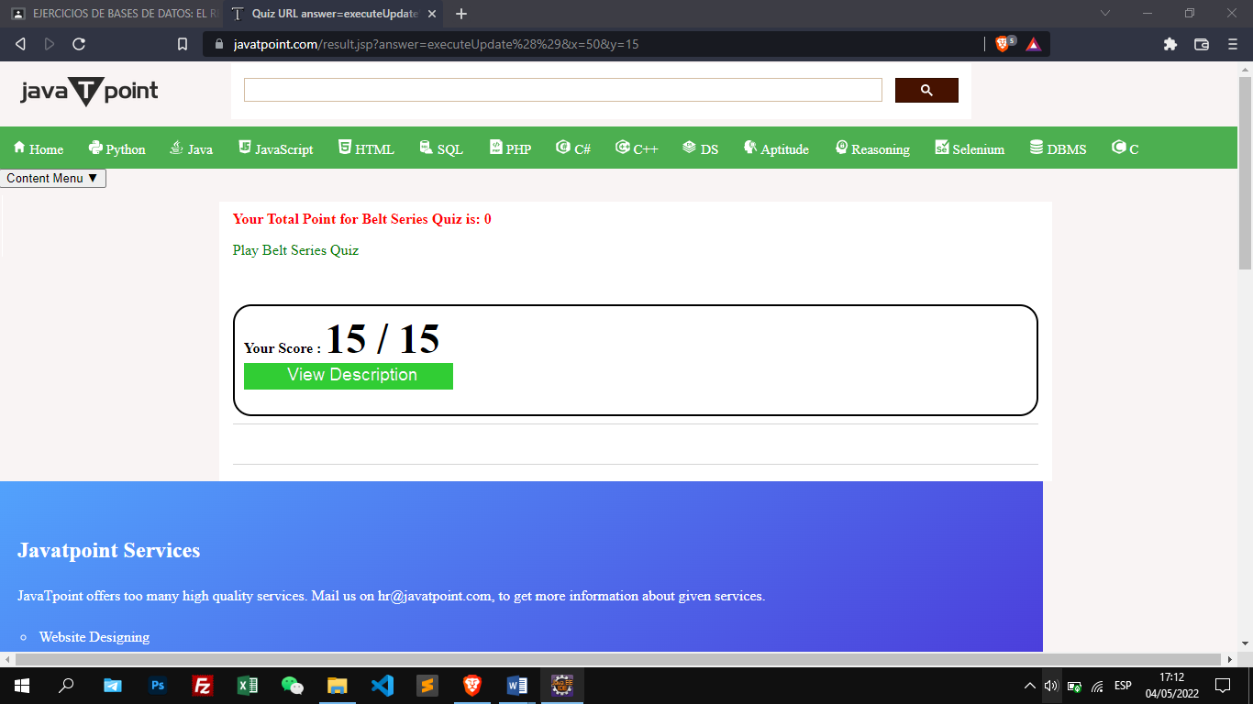

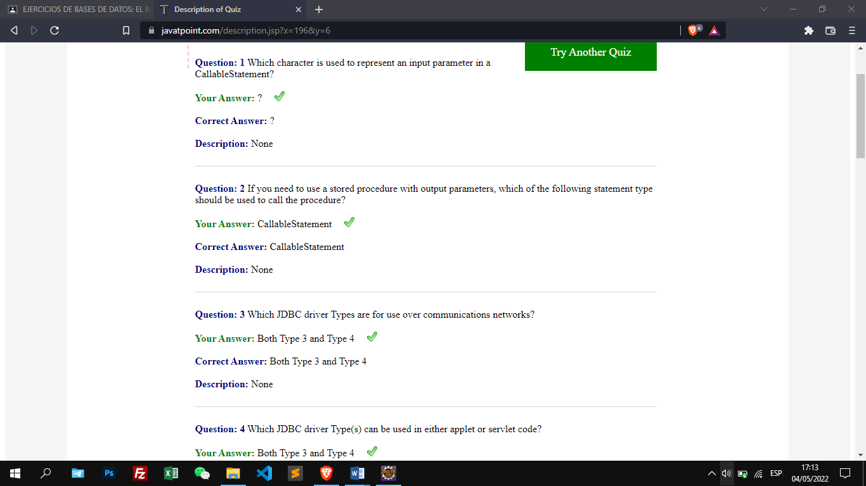

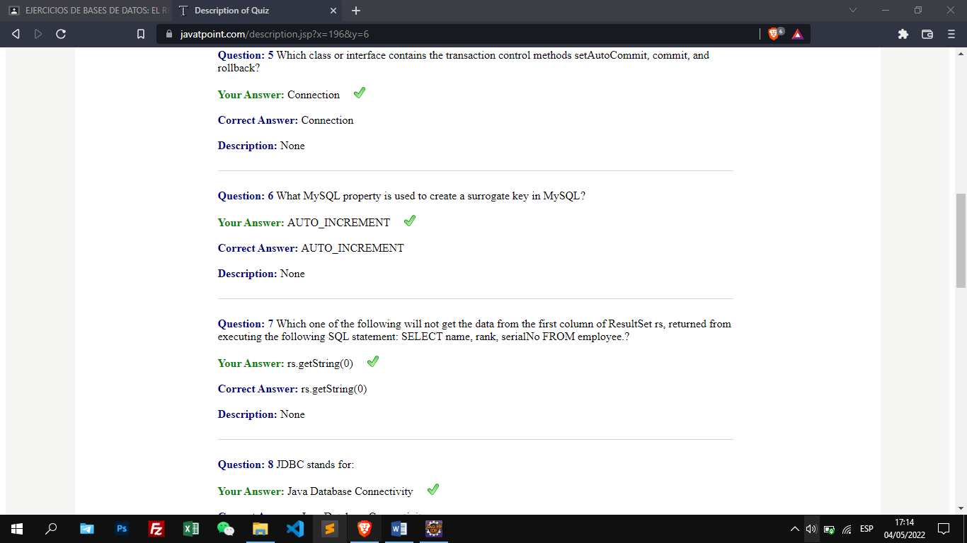

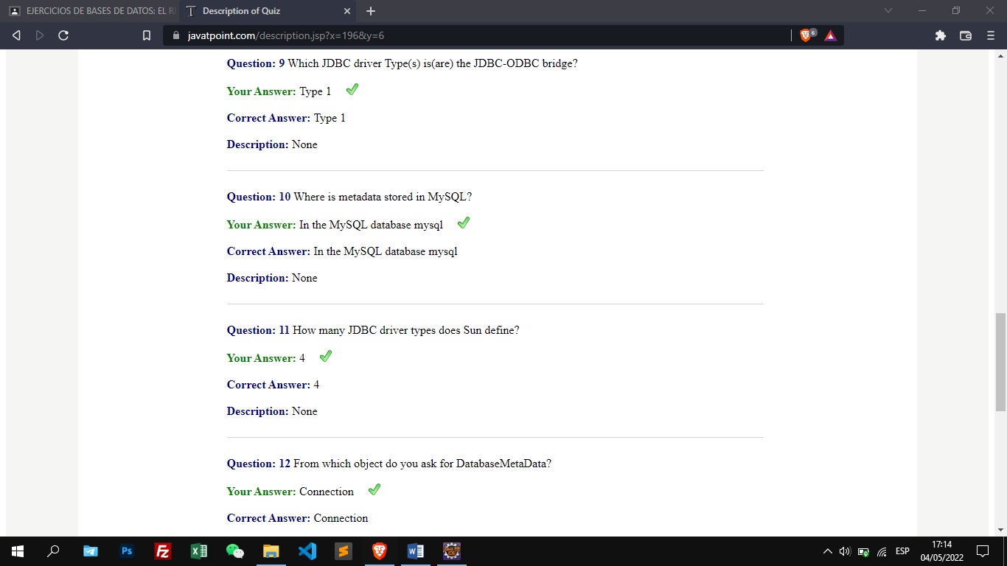

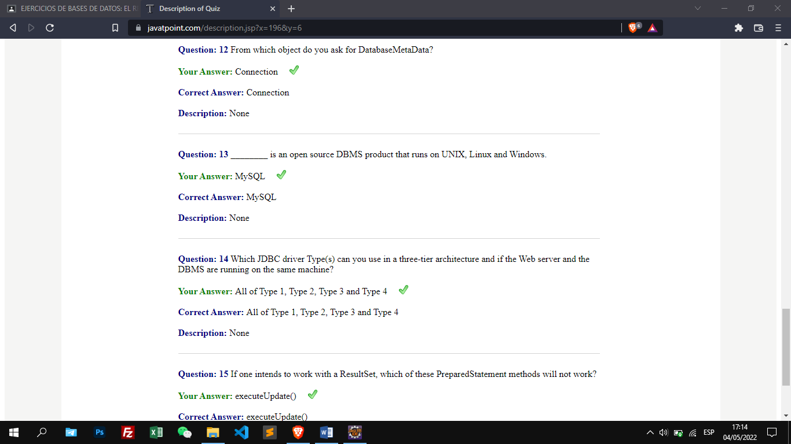

* ***Quiz 2***

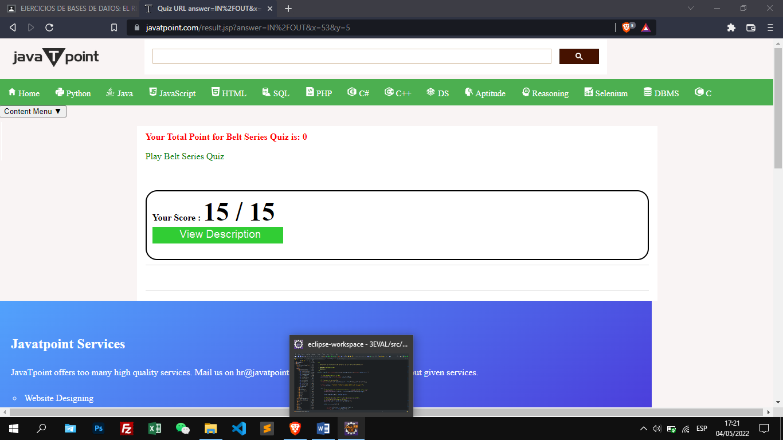

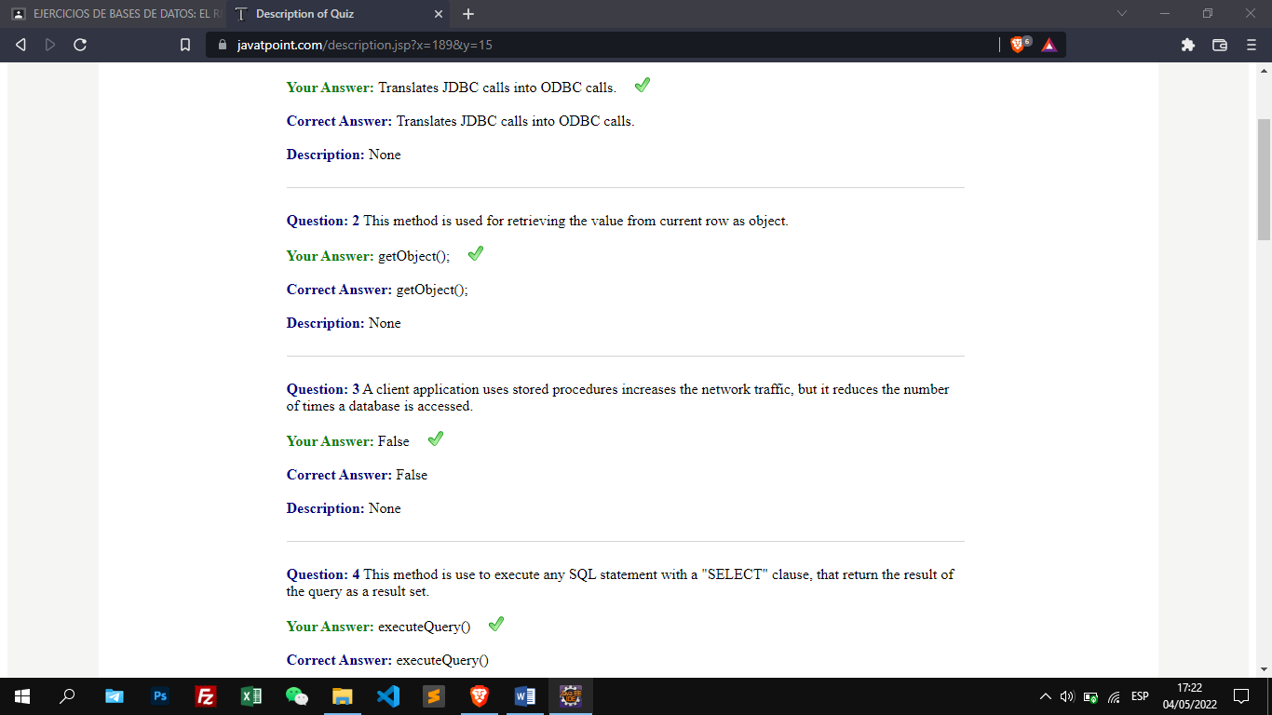

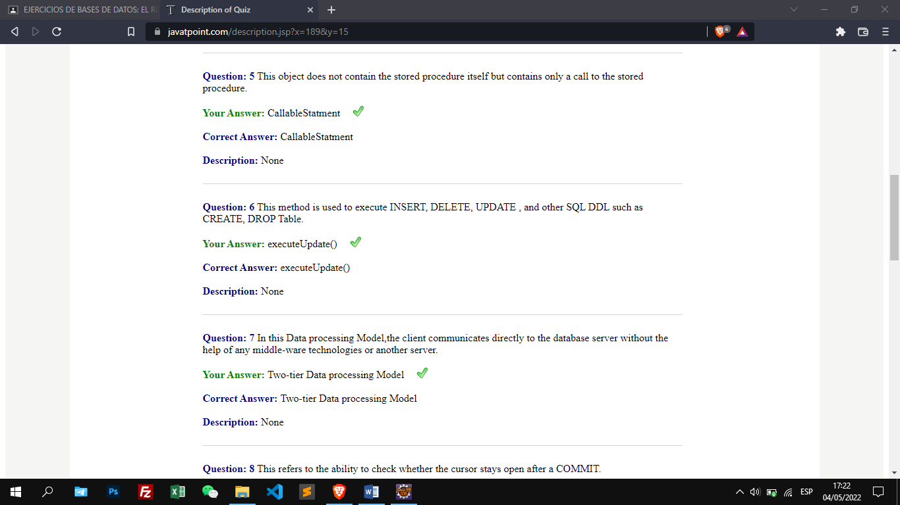

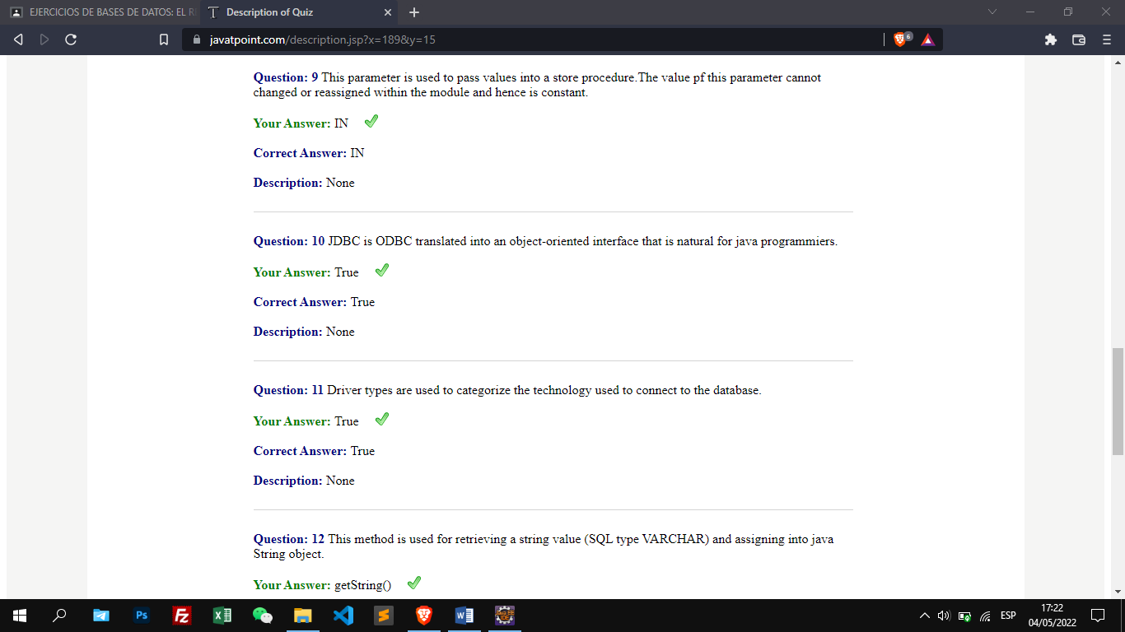

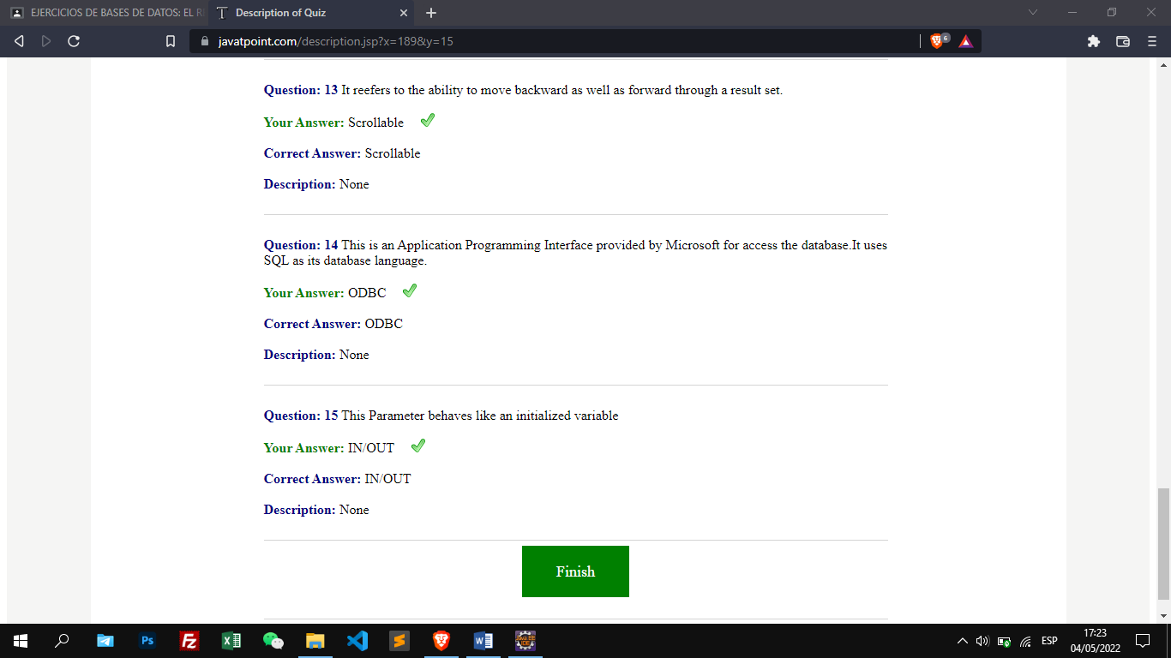

* ***Quiz 3***

